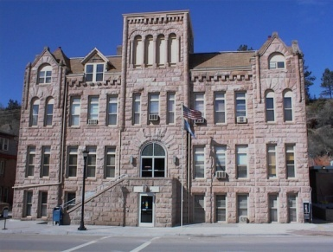
FALL RIVER COUNTY
COUNTY COMMISSIONERS
COURTHOUSE
906 NORTH RIVER ST
HOT SPRINGS, SOUTH DAKOTA 57747
PHONE: (605) 745-5130 FAX: (605) 745-6835

FALL RIVER BOARD OF COUNTY COMMISSIONERS
Second Floor Courtroom
Tuesday, January 17, 2017
8:30 Commission review of bills
9:00 Call Meeting to Order
Pledge of Allegiance
Conflict Of Interest Items for Board Members

Action Items for Consideration:
*Agenda
*Minutes for December 20 & December 29, 2016 & January 3, 2017
*County assistance- 2017-01, death expense applications
*Appoint Commissioner to Public Transportation Board (Prairie Hills Transit)
* New Officials workshop, Pierre, SD on March 15 and 16, 2017
*Pay increase for Alex Bucholz effective 12/29/16 to $15.05 and Stephen Yenulonis effective 12/29/16 to $17.50, both as per Union Contract
(Move any unfinished business to the end of the meeting if needed)

9:10 Frank Maynard, Emergency Management- 2016 Snow Disaster Resolution; Snow Removal; Volunteer list; Travel approval for NFIP in Rapid City, March 20-23, 2017; Updates
9:20 Patricia Logue- Cots and blankets for stranded travelers
9:30 Joe Falkenburg, Commissioner-Letter to Congressional members regarding loss of private lands to public entities; Review letter from Fall River Conservation District
9:40 Jim Sword, State’s Attorney- Coroner policy on asset collection for indigent burials
9:50 Jackie Waldner, Community Nurse-Quarterly report
10:00 Randy Seiler, Highway Superintendent- Fuel bids; Fuel transfers; Surplus 4 Balderson wing plow, appoint appraisers and request sealed bids to be opened at 10:15 am February 7, 2017; Updates
10:20 Approve Bills & Break
10:25 Public Comment
10:30 Kelli Rhoe, Treasurer - Revised Delinquent payment agreement for Laurie Tidball
10:40 Susie Simkins- Travel approval for Mardoqueo Harrington for Advanced Basics for Assessors on April 24-28 in Yankton, Updates
10:50 Paul Nabholz, Commissioner- Video taping Commissioner meetings for the public

Executive Session as per SDCL 1-25-2 (1) and (3), personnel matters and legal for possible action on Union Contract

Adjourn

Agendas are set 24 hours prior to a meeting, any items added at the meeting will be heard for informational purposes only, If any items require action, such action will be deferred to the next meeting.
Fall River County fully subscribes to the Americans with Disabilities Act. If you desire to attend this public meeting and are in need of accommodations, please notify the commissioners’ office, (605) 745-5132, 24 hours prior to the meeting so that appropriate services and auxiliary aids are available.

