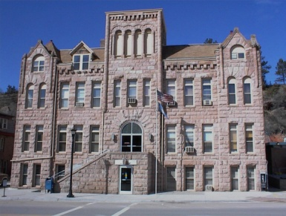
FALL RIVER COUNTY
COUNTY COMMISSIONERS
COURTHOUSE
906 NORTH RIVER ST
HOT SPRINGS, SOUTH DAKOTA 57747
PHONE: (605) 745-5130 FAX: (605) 745-6835

FALL RIVER BOARD OF COUNTY COMMISSIONERS
Courthouse, 2nd Floor Courtroom
TUESDAY, MAY 17, 2016
8:30 Commission review of bills
9:00 Call Meeting to Order
Pledge of Allegiance
Conflict Of Interest Items for Board Members
Action Items for Consideration:
Agenda
Minutes of 4-26-2016 & 5-3-2016
County assistance, death expense applications
Set Personnel Policy meeting to review changes and suggestions from supervisors
Set date to meet with Local 620 to begin contract negotiations

(move any unfinished business to the end of the meeting if needed)
9:10 Susie Simkins, Dir of Equal- Travel for Assessors to Chamberlain on June 8 & 9; Introduce Ted Goslinga of Vanguard
9:20 Keith Andersen, Andersen Engineering – Plat: Caroline Curl
9:25 Lyle Jensen- Bldg Supervisor- Golden West billing on Security locks; request for Health Insurance for Kraima
9:35 Frank Maynard, Emergency Management-Three County Emergency exercise Brief; updates
9:45 Sue Ganje, Auditor; Melody Engebretson, Register of Deeds; Kelli Rhoe, Treasurer- Travel for Deputies to Pierre Deputy Workshop on June 15, 2016
10:00 Highway Business- updates
10:15 Approve bills; break
10:25 Public comment
10:35 Executive Session as per SDCL 1-25-2 (1) and (3), legal and personnel matters – Possible action on wages for Edie Jenniges
11:00 Malt Beverage License Hearing
11:10 Unfinished Business

Adjourn as the County Commissioners
Policy Meeting- request for Commissioner comments

Agendas are set 24 hours prior to a meeting, any items added at the meeting will be heard for informational purposes only, If any items require action, such action will be deferred to the next meeting.
Fall River County fully subscribes to the Americans with Disabilities Act. If you desire to attend this public meeting and are in need of accommodations, please notify the commissioners’ office, (605) 745-5132, 24 hours prior to the meeting so that appropriate services and auxiliary aids are available.

