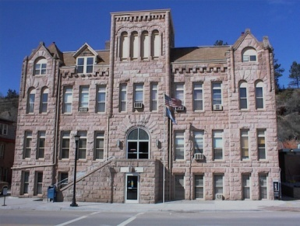
FALL RIVER COUNTY
COUNTY COMMISSIONERS
COURTHOUSE
906 NORTH RIVER ST
HOT SPRINGS, SOUTH DAKOTA 57747
PHONE: (605) 745-5130 FAX: (605) 745-6835

FALL RIVER BOARD OF COUNTY COMMISSIONERS
Second Floor Courtroom
Tuesday, July 18, 2017

8:00 Commission review of bills

9:00 Call Meeting to Order
Pledge of Allegiance
Conflict of Interest Items for Board Members
Action Items for Consideration:
*Agenda
*Minutes of July 6, 2017
*County assistance; Death expense applications (with coroner recommendation)
*Designate an alternate for the BH Council of Local Government board

(Move any unfinished business to the end of the meeting if needed)

9:05 Ali DeMersseman, BH Council of Local Governements – Updates on activities; CDBG grant available for BBB (Bulldoze, Build and Beautify)

9:15 Sue Ganje, Auditor – Review of new codified law change on Campaign Finance

9:20 Susie Simkins, Director of Equalization – AY18 – Ag productivity numbers, Ag classification discussion

9:25 Frank Maynard, Emergency Management – Discuss surplus of search and rescue vehicle
PDM grant application approval
Updates

9:30 Lyle Jensen, Building Supervisor – 2 Handicap door opener quotes
2018 budget
Golden West quotes for network at the South Annex

9:35 Dan Cullen, Veteran’s Service Officer – Quarterly report

9:40 Donna Behrens – 2018 Budget

9:45 Paul Nabholz – School Public Lands Lease (Black Hills Army Depot/Seismic Drilling)
35 mph speed limit on Memorial Road, possible action taken
Information from Deputy Sheriff Lyle Norton on 4 man cells

9:55 Supplemental Budget Hearing

10:00 Randy Seiler, Highway Superintendant – Fuel Quotes
Updates

10:15 Bills; Break

10:20 Public Comment

10:25 Joe Falkenburg – Discussion on Flight for Life Insurance

10:35 2018 PILT – Discuss possible action, apportionment of 2018 PILT Monies, if received.

10:50 Doug Kinniburgh, SD DOT – Updates on Chilson and Igloo Bridges
Wheel Tax

11:20 Mike McNeill and Kelly Stover, US Forest Service – Update on the process for developing conditions for approval of Seismic Drilling

11:35 Cindy Brunson – School & Public Land Oil and Gas Leases, request letter to the state; Locked gate issue

11:45 Bob Evans, Sheriff – Hire approval for Deann Arneson in 24/7
2018 Budget
Temporary hire approval for Phil Shively (Certified Reserve), Jeremy Herrberg (Certified Law Enforcement), Ryan Walz (Certified Reserve)
11:50 Break for lunch

1:30 2018 Budget work
Executive Session as per SDCL 1-25-2, personnel matters (1); SDCL 1-25-2, legal
Commissioner Tour of South Annex; decision on use
Adjourn

Official agendas are set 24 hours prior to a meeting, any items added at the meeting will be heard for informational purposes only. If any items require action, such action will be deferred to the next meeting. **Note, Preliminary shut off for agendas is Thursday at 5:00 pm for Tuesday meetings to allow information to be sent out to Commissioners. Fall River County fully subscribes to the Americans with Disabilities Act. If you desire to attend this public meeting and are in need of accommodations, please notify the commissioners’ office, (605) 745-5132, 24 hours prior to the meeting so that appropriate services and auxiliary aids are available.

