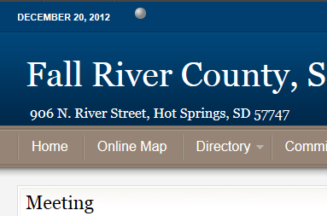
Fall River County Online Mapping
http://fallriver.sdcounties.org
On Menu select “Online Map”

Accept the disclaimer *it is important to note that this map is meant for general reference purposes and some areas of the map are more accurate than others. It is also important to be aware that aerial photography does not always align exactly with the ‘lines’ of the map.
On the right:

Layers –check and uncheck boxes to turn information on and off; information is grouped by topic, group can be turned on and off all together
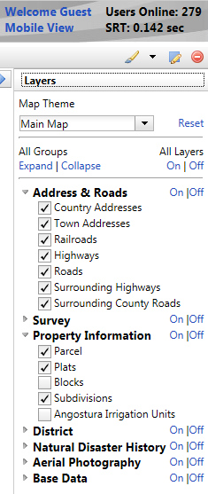

Information – This tab will automatically open when you have clicked on a map item, it will show you the attributes of the map item selected
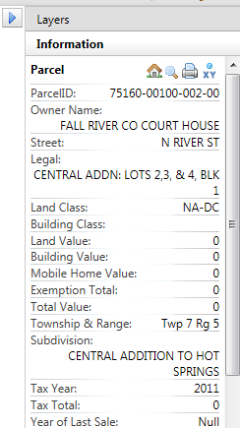

Legend – This tab will show you the symbols being used in the map and what they represent

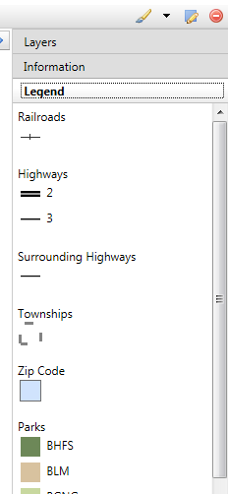

On the left:

Quick Search – These are all individual searches. Quick search is meant for the most commonly searched items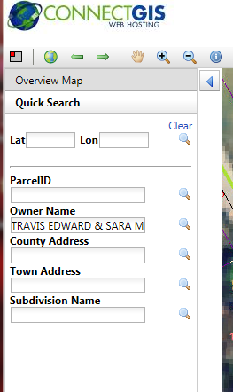

You can search by
- Latitude & Longitude
- Parcel ID number
- Land owner name
- Addresses
- Subdivision

Advanced Search – This tab allows you to do a filtered search (you can search by multiple criteria).
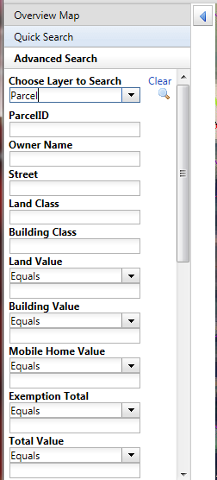
First choose the layer to search then fill in as many criteria as you wish. Numeric fields such as ‘Building Value’ may be search for values “greater than, less than, equal to, or between” the value you enter.
Coordinate Search – Allows for searching of Latitude and Longitude Coordinates.

Comparable Search – This tab allows for searching of map items based on location and similarity to a selected item.
To activate this tab you must first select a map item such as a land parcel. When the information tab appears you will see a ‘house’ icon if this map item allows for comparable searching.
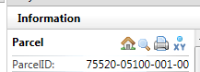
Clicking on the ‘house’ icon will open the comparable search tab (click ‘ok’ to the reminder box that appears). These are similar to advanced searches; you can use many or few filters.
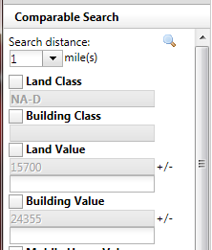
Text fields will match exactly, numeric fields allow you to create a range around the value.

Move Map

Zoom in & out
Buffer Settings
Measure Tool
Buffer
Email
Identify Feature
Previous Extent
Zoom to County
Print & Email Settings
Latitude/Longitude

Print

Find a Property from its Legal Description:
You need to find a property listed in the newspaper for auction. The property is a vacant lot, they only know the legal description: Pine Shadows Subdivision: Lot 14, Block 2.
- Quick Search: >> Subdivision Name: >> (enter subdivision name)
- Under the Layers Tab turn on the layer “Blocks”, Choose the Zoom in tool and draw a box around Block 2
- Under the Layers Tab turn on the layer “Plats”, located lot 14, used the Identify tool to click on lot 14. The information tab will appear on the right showing you the parcel number and other attributes.
Try this again for finding: Birdsell Addn: Lot 12, Blk 7.
Fargo Prentice Addition: Lot 42, Blk 17

Find a Property from its Address
13199 N Angostura Rd
- Quick Search:>> County Address:>> (enter address, after typing number a list of possibility will appear choose the correct one and enter twice)
- Using the Identify tool click on the parcel next to the address point. (Turn on the aerial photo if you are unsure which parcel the address point belongs to.)
Try this again using your own address.
Create a List of Owners:
By Multiple Filter Search
A new road district is being discussed for Cobblestone Mountain Estates; you need a list of all the owners with homes in the subdivision.
- Advanced Search:
  - Subdivision: (enter subdivision name)
  - Building Value: (set dropdown to “greater than”, the enter value 10,000)
- Enter twice, this will show you your results, at the bottom scroll through the results table.
- Find the Green X icon just above your results table, click this button, click the download results link, open the download
- Next we want to print a map showing where these properties are: click the printer icon right next to the identify tool, again click the download link. A separate window should appear showing a map of the area you were viewing. Any layer that was turned on in your map will show on this print. Close this window, trying changes some feature of your map (turn the aerial photo on, turn off addresses, etc.) then click the print icon again.
- You can email maps in the same way using the email icon next to the print icon.
Let’s try creating another list. Say you need to find all the commercial properties in Hot Springs with taxes greater than $15,000.
- Advanced Search:
  - Incorporate area:
  - 2012 Taxes:
  - Land Class: (hint: urban commercial is NA-DC)
By Location Search
Let’s create a list based on location instead of attributes. Let’s find all the parcels that are within 100’ of the Hot Springs School Campus.
- Zoom to the Hot Springs School.
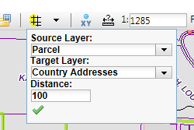
- On the tool bar click the arrow next to the buffer tool.
- Set Source to ‘Parcel’ (source is the layer you wish to use as your center, in this case the school parcel is being used.)
- Set Target to ‘Parcel’ (target is the layer you wish to select information from, in this case the parcels surrounding the school so ‘Parcel’ is being used for both.)
- Set Distance to 100 (distance is always in feet)
- Click the green check mark
- Choose the buffer tool
- Click on the Hot Springs School Campus Parcel
- Results should appear (43 results), click the Green Excel X to download the table
Get Latitude/Longitude Coordinates
Find the Lat/Long Coordinates for Maverick Junction.
- On the tool bar click the tool that has a blue dot with an ‘xy’
- Click on the location on the map you want coordinates for. Results should appear on the left.
Zoom to Latitude/Longitude Coordinates
Find Lat: 43.180337, Long: -103.233702 (You can search for lat/long under quick search or coordinate search

