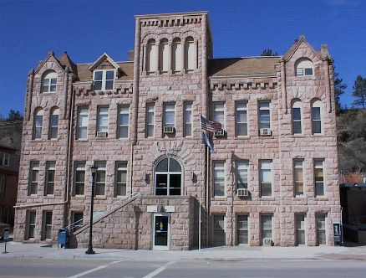
FALL RIVER COUNTY
COUNTY COMMISSIONERS
Fall River County Courthouse
906 North River Street
Hot Springs, South Dakota 57747
Phone: (605) 745-5130, Fax: (605) 745-6835

FALL RIVER BOARD OF COUNTY CONSOLIDATED BOARD OF EQUALIZATION
Second Floor, Courtroom
Thursday, April 30, 2026

Opening Invocation

Pledge of Allegiance

8:30 Call Meeting to Order of the Fall River County Consolidated Board of Equalization; possible action
Conflict of Interest Items for Board Members
Review the following appeals; possible action
- Review of Responsibilities, as detailed by Dept of Revenue; Review Information Packet
- Oath of Office – complete and give to Auditor

8:35 Artz, Kerry, Brenner, Mary *phone conference (City of Edgemont/Edgemont School District)

8:45 Fette, David, June *phone conference (City of Edgemont/Edgemont School District)

8:55 Johnson, Andrew, Louise *phone conference (City of Edgemont/Edgemont School District)

9:05 Appleby (Trust), Bradley (City of Hot Springs/Hot Springs School District)

9:15 Peterson, David (City of Hot Springs/Hot Springs School District)

9:25 Whitman, Anthony *phone conference (City of Hot Springs/Hot Springs School District)

9:35 Weiseler, Donnell, Gloria (Rural/Hot Springs School District)

9:45 Cape, Sean, Molly (Rural/Hot Springs School District)

9:55 Luallin, Randy (Rural/Hot Springs School District)

10:05 Break

10:15 Raml, David, Trisha (Rural/Hot Springs School District)

10:25 Raml David, Trisha (Rural/Hot Springs School District)

10:35 Wiedow, Jeffrey, Deborah (Rural/Hot Springs School District)

10:45 Shiraz INC, Patel, Mina (City of Hot Springs/Hot Springs School District)

11:00 Urban, David & Janice *Phone Conference (Rural/Hot Springs School District)

11:15 Schmidt, Cody (Rural/Hot Springs School District)

11:25 Alberts, Jerrie K (Rural/Hot Springs School District)

**Agendas are set 24 hours prior to a meeting. Any items added to the meeting will be heard for informational purposes only, if any items require action, such action will be deferred to the next meeting.

Fall River County fully subscribes to the Americans with Disabilities Act. If you wish to attend this public meeting and need accommodation, please notify the Auditor’s Office, (605) 745-5130, 24 hours prior to the meeting so that appropriate services and auxiliary aids are available.

The Conference Call information below is assigned for pre-arranged agenda items where the presenter is unavailable in person.

Conference Call information (if applicable): Call (848) 777-1212; Conference ID #37268689

